A Detailed Analysis of Customer Demographics and Income Patterns



**Introduction:**

The purpose of this report is to analyze the customer demographics and income patterns within our dataset. By utilizing Tableau dashboards, we aim to uncover key insights about our customer base, including their occupations, education levels, home ownership status, and income distributions. This analysis will help inform strategic decisions and identify areas for potential growth and improvement.



**Methodology:**

Data for this analysis was sourced from our customer database, which includes attributes such as occupation, gender, marital status, home ownership, first name, last name, and annual income, number of children, education level, and email address. The data was cleaned and preprocessed using Excel to ensure accuracy and consistency. Tableau was selected as the visualization tool due to its powerful features for creating interactive and insightful dashboards.



**Requirement analysis:**

The main requirements for this project included:

- Understanding the distribution of customers by occupation, gender, and education level.

- Analyzing home ownership patterns among customers.

- Examining the relationship between the number of children and home ownership.

- Assessing average income levels by education and occupation.

The dashboards were designed to address these requirements and provide a comprehensive view of the data.

**Visualization:**

**Customer Analysis Dashboard:**

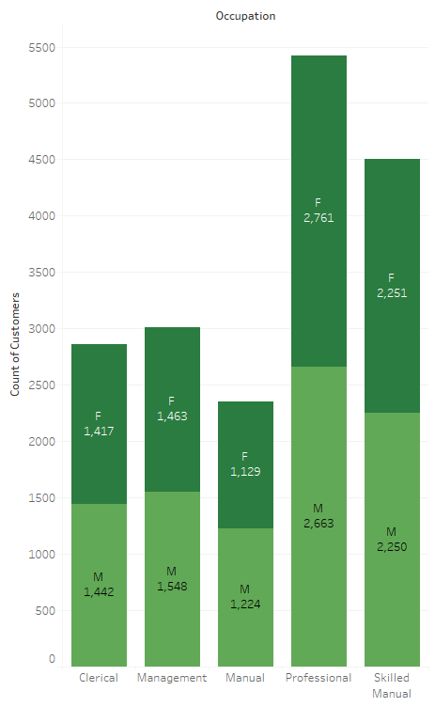

1. **Count of Customers by Occupation and Gender:**

This chart shows the distribution of customers across different occupations, broken down by gender.

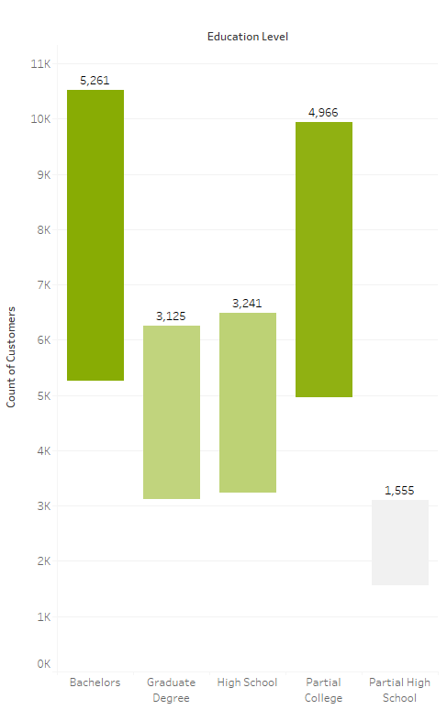

1. **Count of Customers by Education Level:**

Displaying the number of customers at each education level.

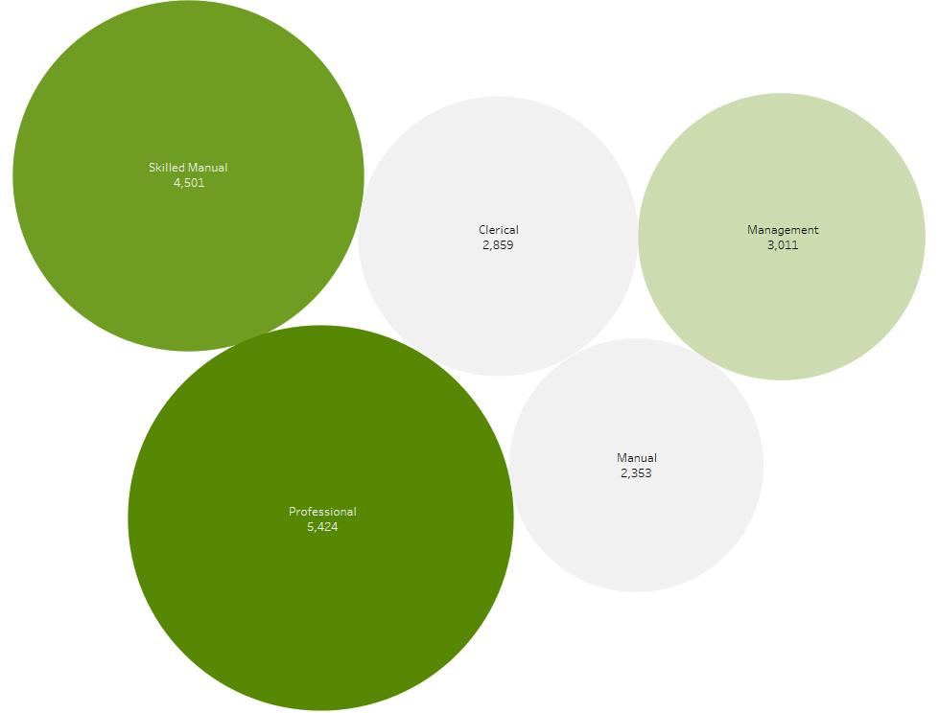

1. **Count of Customers by Occupation:**

Highlighting the most common occupations among customers.

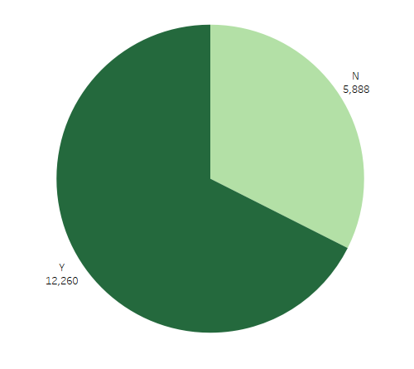

1. **Count of Customers by Home Owners:**

It indicates the proportion of customers who own homes versus those who do not.

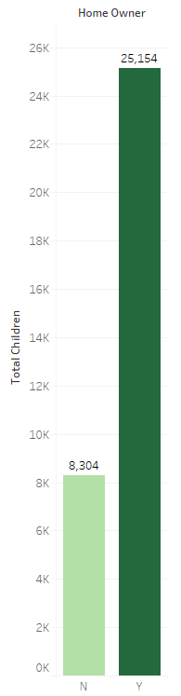

1. **Total Children by Homeowner:**

This chart shows the total number of children for customers who own homes versus those who do not.

**________________________________________________________**

**Income Analysis Dashboard:**

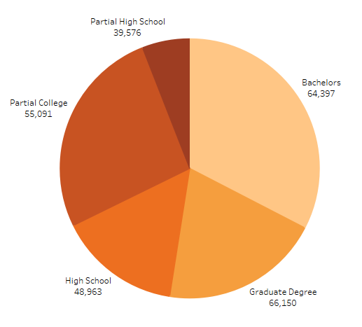

1. **Average Income by Education Level:**

This chart shows the average income for customers at different education levels.

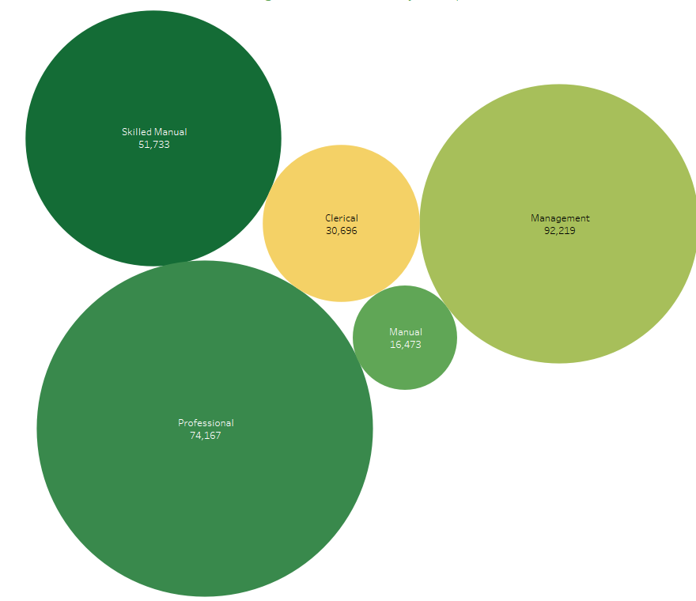

1. **Average Income by Occupation:**

This chart displays the average income for various occupations.

**Insights:**

- The majority of customers are professionals, with a significant gender disparity favoring women in these occupations.

- Bachelors are associated with higher average incomes, particularly for customers with postgraduate degrees.

- Home ownership is more common among customers with higher incomes and more children.

- Customers which are professionals and management positions tend to have the highest average incomes.

- There is a notable difference in the number of children between homeowners and non-homeowners, with homeowners generally having more children.



**Conclusion:**

This analysis provided valuable insights into our customer demographics and income patterns. Key findings include significant gender disparities in certain occupations, the impact of education on income, and the relationship between home ownership and the number of children. These insights can help guide marketing strategies, customer segmentation, and product development efforts. Future analysis could delve deeper into the reasons behind these patterns and explore additional customer attributes.